1st STEP: TO ARRIVE AT MA ON SHAN VILLAGE
2nd STEP: TO TAKE TAXI OR MTR TO
MA ON SHAN MTR STATION (AROUND HK$40).
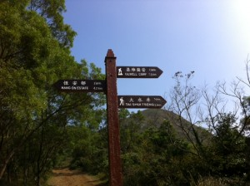
3rd STEP: WALK ALONG TO THE TERMINUS OF THE VILLAGE
BUS (NR84) WHERE THERE IS A STAIRCASE NEXT TO
4th STEP: FOLLOW IT AND THEN TURN RIGHT.
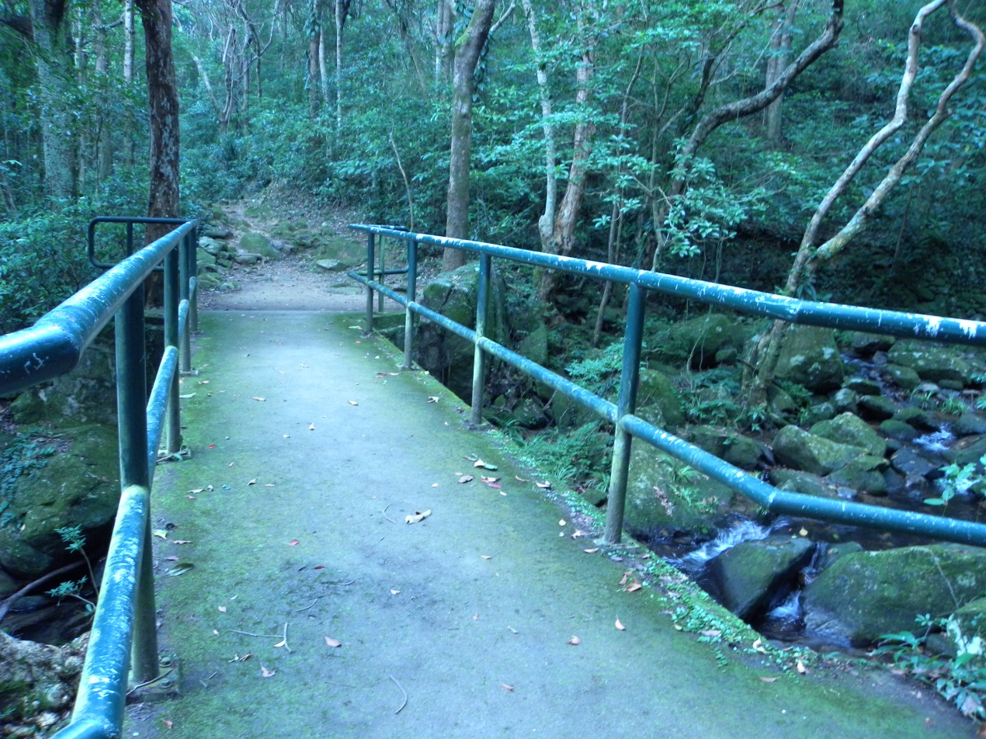
5th STEP: AFTER ABOUT 20 MINUTE WALK, YOU WILL COME
TO AN INTERSECTION WITH A PAVILION.
6th STEP: FOLLOW THE ORIGINAL TRACK.
7th STEP: AT THE NEXT INTERSECTION, TURN RIGHT AND
CHOOSE “MUI TSZ LAM” AND THEN WILL ARRIVE.
